LAB - 11

|  |  |
| --- | --- |
| Name | Keval D Gandevia |
| Roll Number | CE046 |
| ID | 19CEUEG017 |
| Subject | Image Processing |

**Aim:** Implement basic compression techniques.

**Q. 1: Implement Arithmetic Coding and Decoding. A). Take the data set given in the pdf and find the codewords for GERMAN and FRANCE. B). Decode the words from their respective codewords.**

* **Code:**

|  |
| --- |
| *#include* <bits/stdc++.h>  using namespace std;  int main()  {      vector<char> symbol = {'Y', 'E', 'R', 'G', 'N', 'M', 'A', 'F', 'C'};      vector<double> probability = {0.1, 0.2, 0.1, 0.1, 0.1, 0.1, 0.1, 0.1, 0.1};      unordered_map<char, int> indx;      vector<double> rangefrom = {0.0};      vector<double> rangeto = {probability[0]};      indx[symbol[0]] = 0;  *for* (int i = 1; i < symbol.size(); i++)      {          indx[symbol[i]] = i;  *if* (i > 0)          {              rangefrom.push_back(rangeto[i - 1]);              rangeto.push_back(rangefrom[i] + probability[i]);          }      }      string s;      cout << "Enter the string: ";      cin >> s;      double LV_OLD = 0, HV = 1, DIFF = 1, LV;  *for* (int i = 0; i < s.size(); i++)      {          LV = LV_OLD + DIFF * rangefrom[indx[s[i]]];          HV = LV_OLD + DIFF * rangeto[indx[s[i]]];          DIFF = HV - LV;          LV_OLD = LV;          cout << endl               << s[i] << " -> " << LV << " " << HV << " " << DIFF << endl;      }      cout << "\nLV is:" << LV << endl;  *// Decoding Arithmetic code*      double code = LV;      int i;      int len = s.size();      string res = "";  *while* (len != 0)      {  *for* (i = 0; i < symbol.size(); i++)          {  *if* (rangeto[indx[symbol[i]]] > code && rangefrom[indx[symbol[i]]] <= code)              {  *break*;              }          }          res += symbol[i];          code = (code - rangefrom[indx[symbol[i]]]) / (rangeto[indx[symbol[i]]] - rangefrom[indx[symbol[i]]]);          len--;      }      cout << "\nCode:" << res << endl           << endl;  } |

* **Output:**

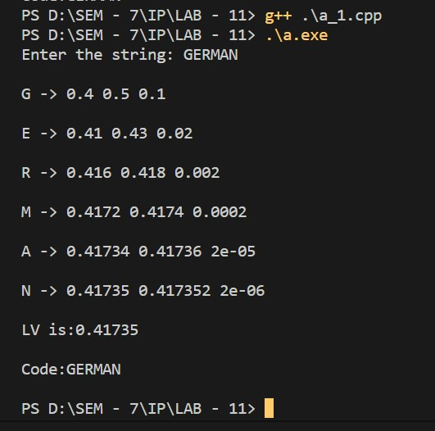

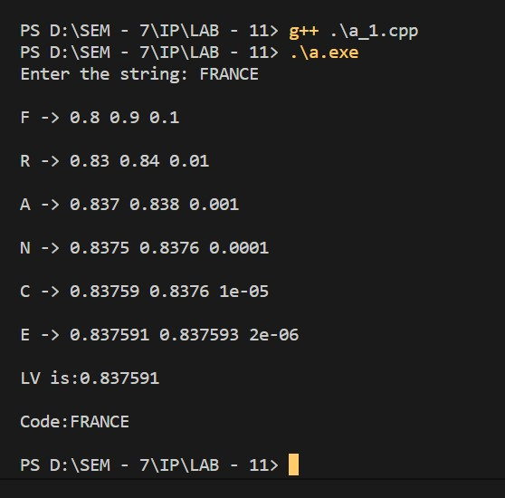

**Q. 2: Implement Huffman Coding and Decoding.**

* **Code:**

|  |
| --- |
| *#include* <bits/stdc++.h>  using namespace std;  class HuffManTree  {  public:      char code;      int freq;      string symbol;      HuffManTree *left, *right;      HuffManTree(string symbol, int freq, HuffManTree *left = NULL, HuffManTree *right = NULL)      {          this->symbol = symbol;          this->freq = freq;          this->left = left;          this->right = right;      }  };  struct CompareFrequency  {      bool operator()(HuffManTree *&p1, HuffManTree *&p2)      {  *// return "true" if "p1" is ordered*  *// before "p2", for example:*  *return* p1->freq > p2->freq;      }  };  void printHuffMan(HuffManTree *root, string codes = "")  {  *if* (!root->left and !root->right)      {          codes.push_back(root->code);          cout << root->symbol << " -> " << codes << endl;          codes.pop_back();  *return*;      }      codes.push_back(root->code);      printHuffMan(root->left, codes);      printHuffMan(root->right, codes);      codes.pop_back();  }  int main()  {      vector<char> symbols = {'A', 'B', 'C', 'D', 'E'};      vector<int> frequency = {30, 30, 15, 15, 10};      priority_queue<HuffManTree *, vector<HuffManTree *>, CompareFrequency> pq;  *for* (int i = 0; i < symbols.size(); i++)      {          string tt = {symbols[i]};          pq.push(new HuffManTree(tt, frequency[i]));      }  *while* (pq.size() > 1)      {          HuffManTree *temp1 = pq.top();          pq.pop();          temp1->code = '1';          HuffManTree *temp2 = pq.top();          pq.pop();          temp2->code = '0';          pq.push(new HuffManTree(temp1->symbol + temp2->symbol, temp1->freq + temp2->freq, temp1, temp2));      }      HuffManTree *root = pq.top();      printHuffMan(root);  } |

* **Output:**

